**Creating databases:**

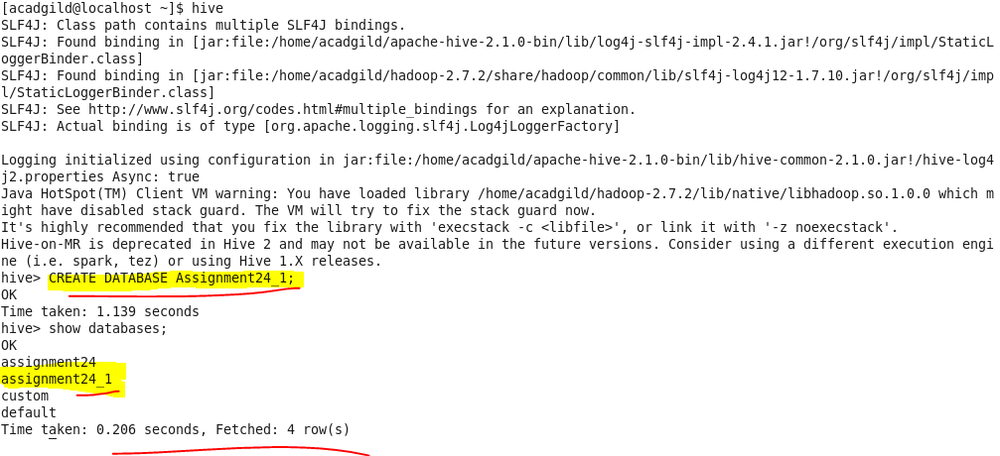

**Creating table:**



**Loading data :**

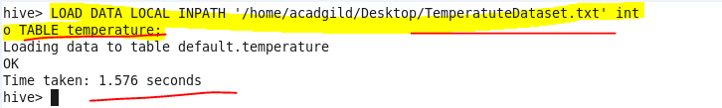

**Fetch date and temperature from temperature_data where zip code is greater than 300000 and less than 399999:**

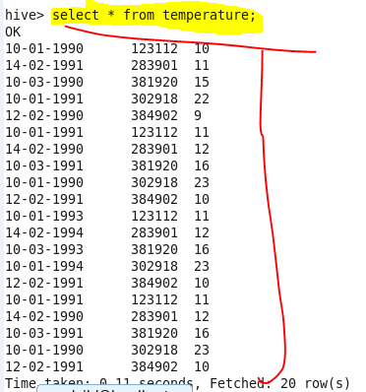

**Calculate maximum temperature corresponding to every year from temperature_data table:**

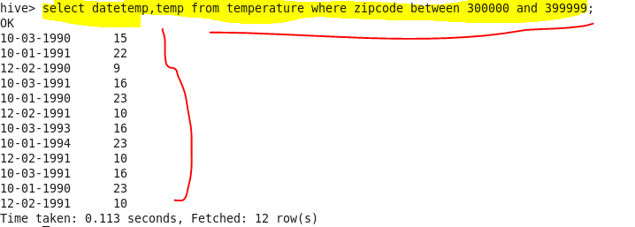

**Calculate maximum temperature from temperature_data table corresponding to those years which have at least 2 entries in the table:**

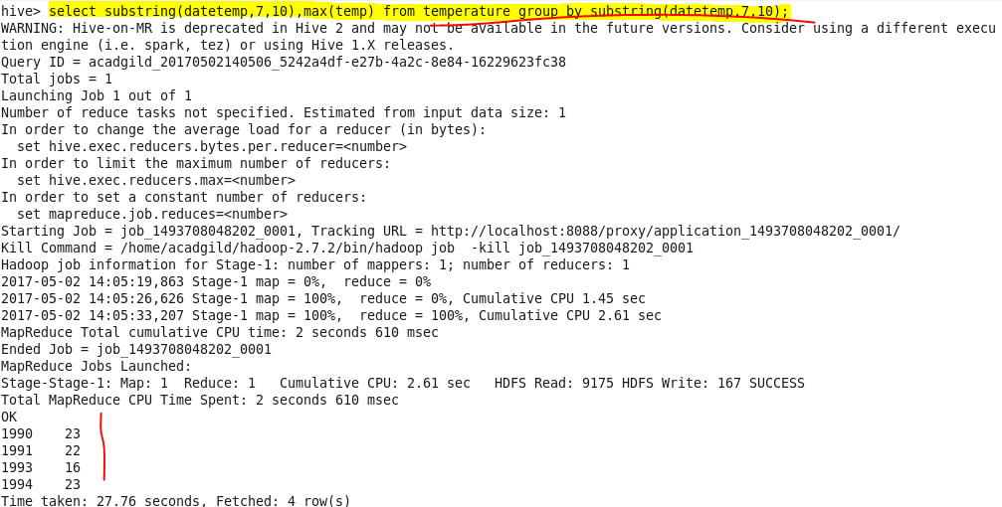

**Create a view on the top of last query, name it temperature_data_vw:**

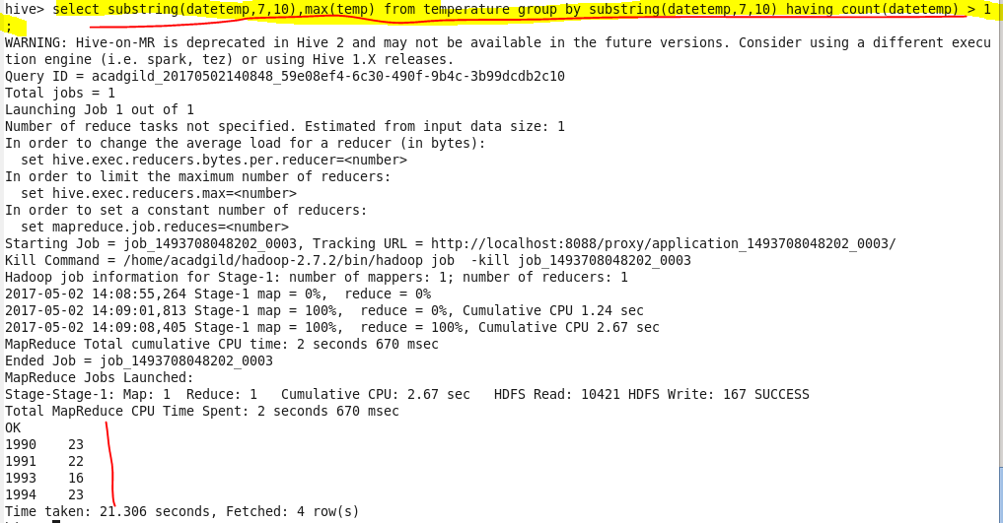

**Output:**



**Export contents from temperature_data_vw to a file in local file system, such that each file is '|' delimited:**

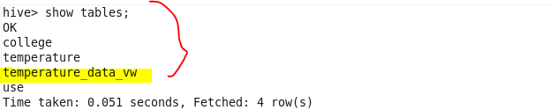

**We can see the data in our local file:**

